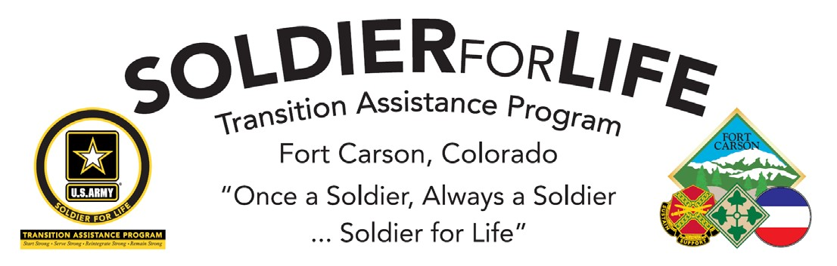
EMPLOYER DAY
AUSTIN, TEXAS
POLICE DEPARTMENT

Transitioning Soldiers, Veterans, and Family Members

WEDNESDAY, 22 AUGUST 2018
10:00 AM – 2:00 PM
ROOM 101

Building 6237, 1626 Elwell Street, Fort Carson (across the street from Carson Middle School)

