**United States**[](http://fsweb.psicc.r2.fs.fed.us/fsweb.shtml)**Forest Service**

**Outreach Notice**

**Region 2**

**Pike & San Isabel National Forests/Cimarron & Comanche National Grasslands**

**Pike National Forest and San Isabel National Forest**

**Notice valid through October 10, 2018**

# Engineering Technician (Civil)

# GS-0802-5/6/7/8/9

# One Vacancy To Be Filled

Organizational Unit: R2 - Pike and San Isabel National Forests and Cimarron and Comanche National Grasslands, Physical Resources Staff Area

Opportunity Type: Pre-announcement

Primary Contact: Lacie Davilman, Forest Engineer, [ldavilman@fs.fed.us](mailto:ldavilman@fs.fed.us) (719-553-1492)

We are filling one vacancy. One position will be located at the Supervisor’s Office in Pueblo, CO. These positions will be posted on [www.usajobs.gov](http://www.usajobs.gov) in on or around 10 October 2018 and may be open for only a short time period. Outreach respondents will be notified when the announcement is posted.s

# Position Details

# **Position Description**

This position is located within the Supervisor’s Office in Pueblo, CO. The incumbent reports to the PSICC Engineering Program Manager (Forest Engineer), who is located in Pueblo, Colorado. Incumbent is responsible for the Travel Management Program, the Motor Vehicle Use Maps, and participates actively in interdisciplinary planning efforts, ensuring compliance and conformance to transportation planning and travel management regularions and has knowledge and experience in use of GIS Programs, Database Software, Surveying Equipment and Methodologies, and Travel Management Regulations. This individual will get the opportunity to work on all districts of the PSICC.

We are looking for a recent graduate who excels at attention to detail, has excellent comprehension and written communication skills, is comfortable with interacting with individuals on all 6 districts and both Grassland units, and, ideally, a love of the outdoors and a passion for resource management.

Major Duties

Provides technical advice and assistance in the area of transportation system planning.

Assists in developing an integrated transportation system plan for the unit with the use of a Geographical Information System (GIS), Infrastructure (INFRA) database, aerial photos, topographic and geologic maps, and on-the-ground reconnaissance.

Collects pertinent data and assists in preparation of National Environmental Policy Act (NEPA) documents in regards to environmental analysis, environmental impact statements, and special reports with regard to transportation engineering.

Provides engineering input during the interdisciplinary planning process for activities involving the transportation system and assists in the preparation of engineering specialist’s reports for environmental analyses.

Analyzes existing roads and trails for feasible alternatives that better serve transportation management objectives.

Assists in preparing economic analysis of transportation management alternatives considering the costs of operations and maintenance, replacement, reconstruction, or closure, along with resource costs and benefits.

Prepares project plans for a transportation system, including overall project scheduling, major engineering requirements and budgetary costs.

**CIMARRON NATIONAL GRASSLAND**

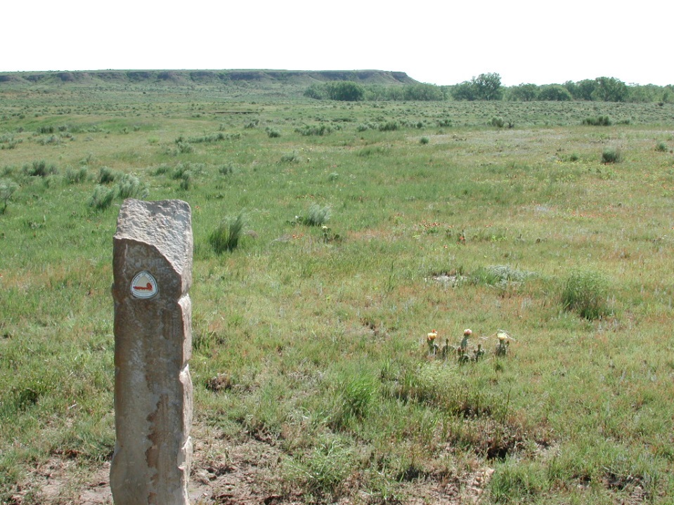The Cimarron National Grassland is located in the southwest corner of Kansas, with the District office being located in Elkhart, KS. The Cimarron National Grassland covers just over 100,000 acres of public land that is managed for multiple resources use including range, minerals, wildlife, water, fire, developed and dispersed recreation. The historic Santa Fe Trail goes through the Cimarron National Grassland.

**COMANCHE NATIONAL GRASSLAND**

The Comanche National Grassland is located in southeastern Colorado, with District offices in Springfield, CO and La Junta, CO. The Comanche National Grassland covers over 440,000 acres of public land that is managed for multiple resources use including range, minerals, wildlife, water, fire, developed and dispersed recreation. The Comanche National Grassland is home to the internationally known dinosaur trackway in Picketwire Canyon, and has abundant archeological sites throughout the area.

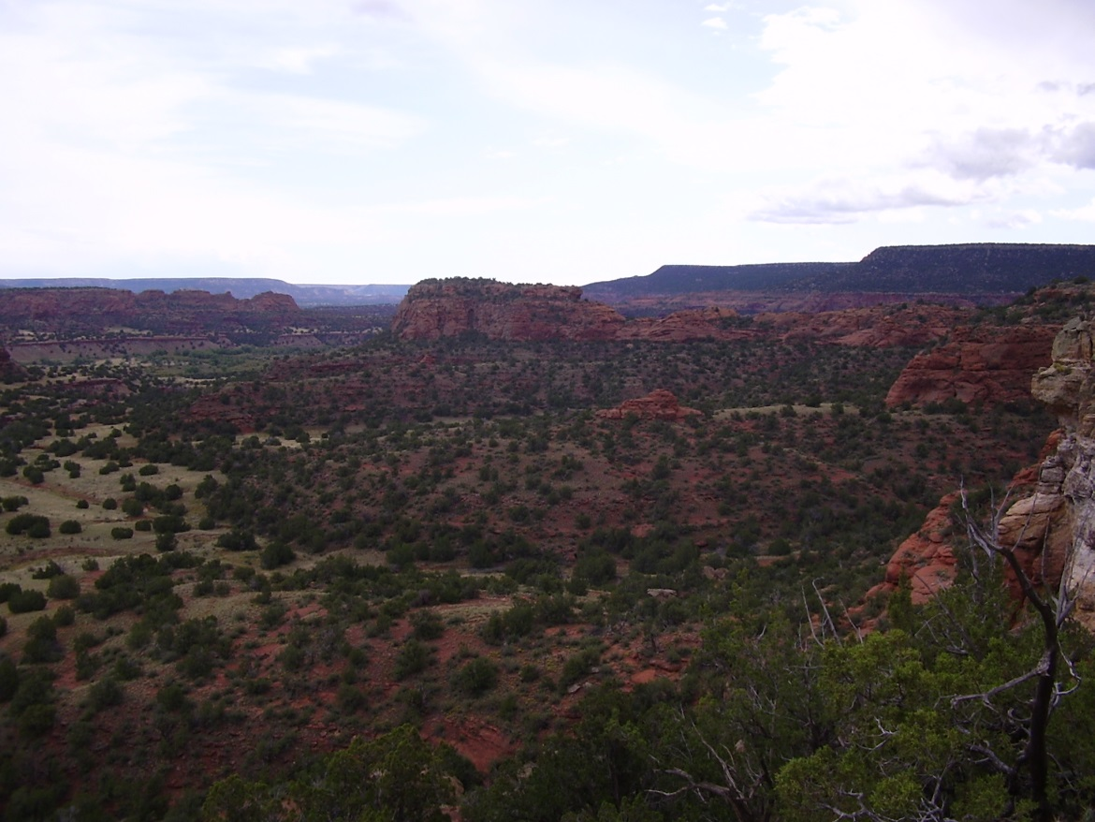

**LEADVILLE RANGER DISTRICT**

The Leadville Ranger District is located in the San Isabel National Forest and covers both Lake and Chaffee counties. Leadville serves as the headwaters of the Arkansas River. The Leadville Ranger District is the highest ranger district in the Forest Service System with elevations ranging from 8,000 to 14,400 feet.  The majority of the 289,000 acre district is above 10,000 feet and located within inventoried roadless areas or Congressionally-designated Wilderness Areas.

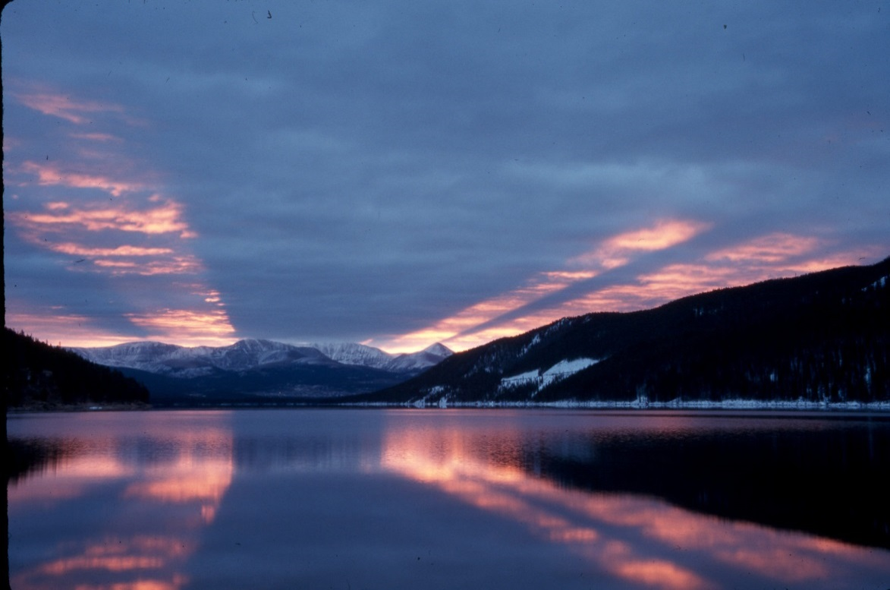

**PIKES PEAK RANGER DISTRICT**

The Pikes Peak Ranger District is located in central Colorado with the District Office being located in Colorado Springs, the second largest city in Colorado. The District is located on the Pike National Forest and covers roughly 230,000 acres, which are managed for multiple resources use including range, minerals, wildlife, water, fire, developed and dispersed recreation. The Pikes Peak Rager District is home to the Pike Interagency Hotshot Crew as well as a helitack module.

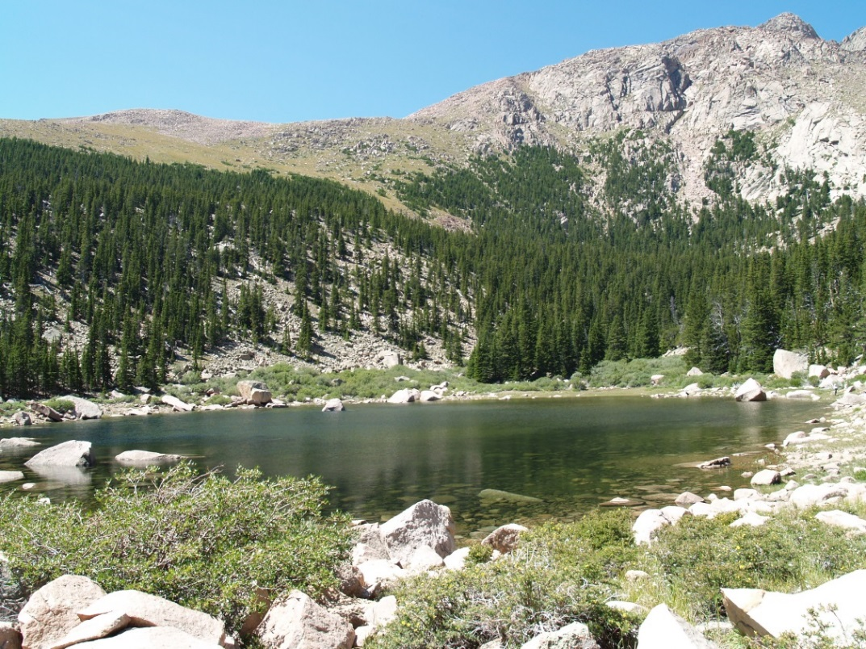

**SALIDA RANGER DISTRICT**

The Salida Ranger District covers 448,885 acres across five counties. Three wilderness areas are located on the District with a fourth area proposed on BLM land directly adjacent to National Forest and Browns Canyon. The Ranger District is located in the “Home of the Fourteeners” with fourteen thousand foot peaks towering over the western side of the valley.

[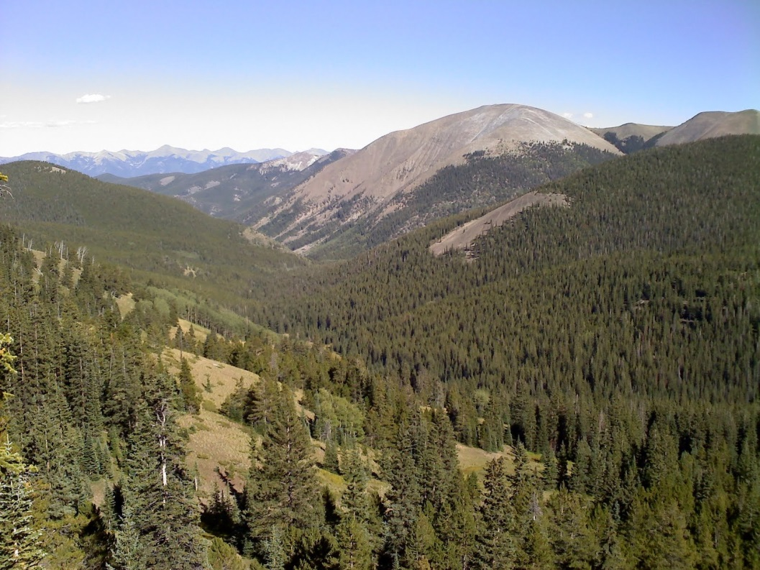](http://r.search.yahoo.com/_ylt=AwrTcXxSDzNTNk8AHbmjzbkF;_ylu=X3oDMTBpcGszamw0BHNlYwNmcC1pbWcEc2xrA2ltZw--/RV=2/RE=1395883986/RO=11/RU=http:/dryfliesfattires.blogspot.com/2010/09/marshall-pass.html/RK=0/RS=IWKZ3r0JqEkzz9O0aQMKrHOwycY-)

**SAN CARLOS RANGER DISTRICT**

The San Carlos Ranger District encompasses the south portion of the San Isabel National Forest. The District extends over an area about 50 miles wide, by 110 miles long, including about 400,000 acres of National Forest System lands in Fremont, Custer, Huerfano, Pueblo, Las Animas & Costilla Counties.

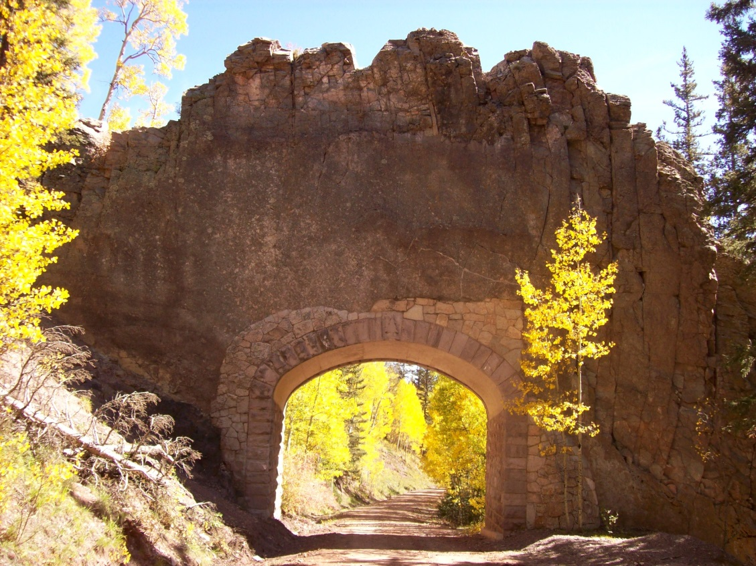

**SOUTH PARK RANGER DISTRICT**

The South Park Ranger District office is located in Fairplay, Colorado, and covers Park and Teller counties. The district is approximately 540,000 acres in size, including two Wilderness areas. Elevations range from 8,000 to over 14,000 feet. Fairplay lies within the geographic feature of “South Park.” South Park covers over 900 square miles and is surrounded by the Mosquito, Park, Platte River, Kenosha, and Tarryall mountain ranges.

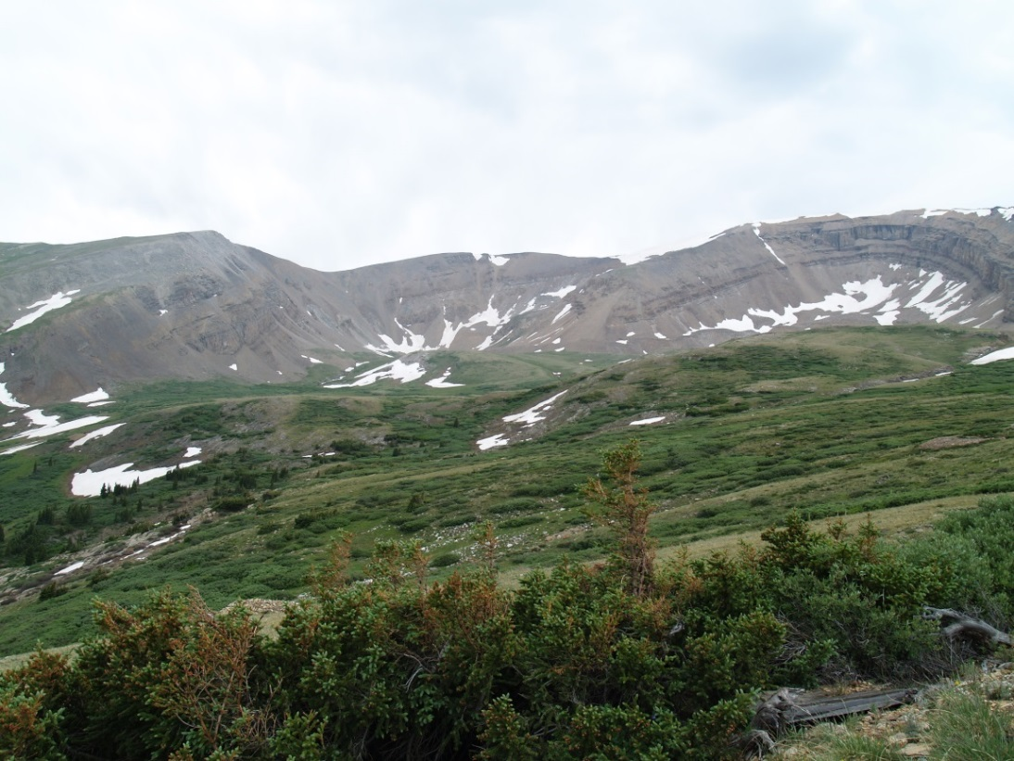

**SOUTH PLATTE RANGER DISTRICT**

The 460,000 acre South Platte Ranger District lies adjacent to southwest metropolitan Denver, outside the town limits of Morrison, CO. It lies due west of the Denver Metropolitan area in Jefferson, Park, Douglas, Teller, and Clear Creek Counties. The South Platte Ranger District houses the Region 2 Speciality Mule Packstring, as well as Devil’s Head Fire Lookout Tower.

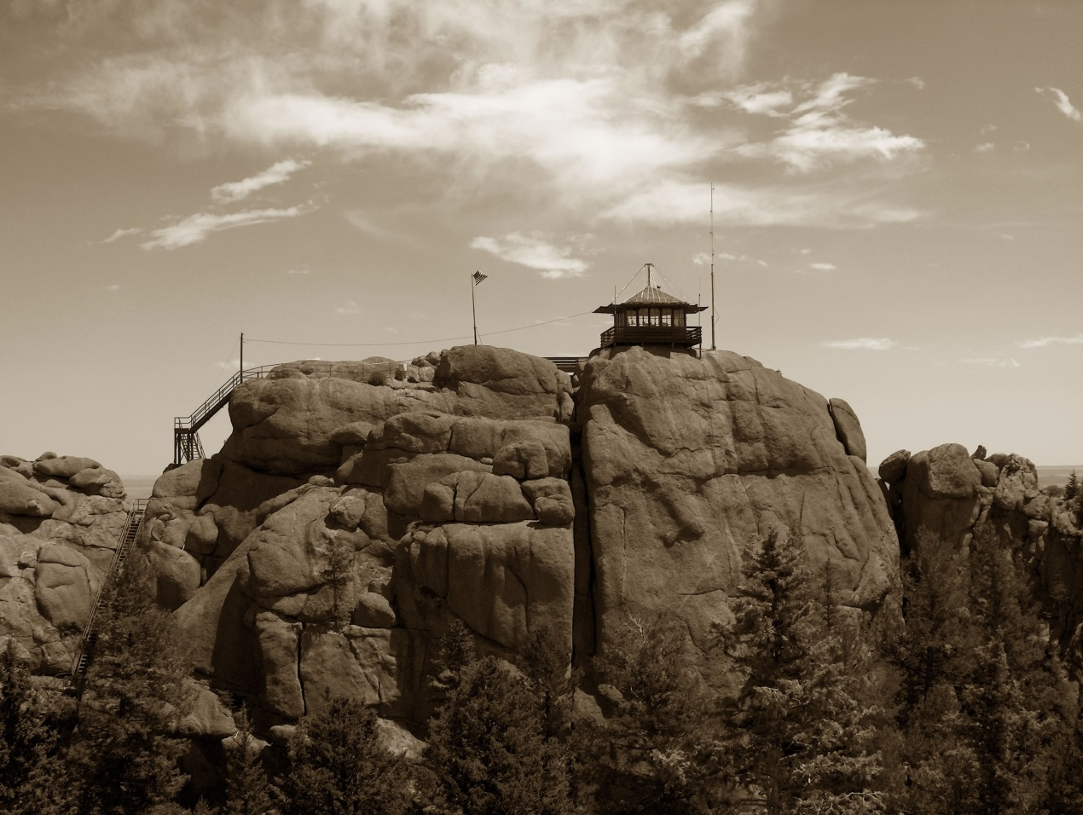

# Duty Station SpecificsPike and San Isabel National Forests and Cimarron and Comanche National Grasslands Supervisors Office located in Pueblo, CO.

## Community InformationELEVATION: 4,662 feet

POPULATION: Pueblo County 161,875; City of Pueblo 108,249;

DIVERSITY MAKEUP - Based on 2010 Census Information: 45% White; 50%

Hispanic; 2% Black; 2% American Indian/Alaska; 1% Asian

NEAREST LARGER CITIES: Colorado Springs, 45 miles and Denver, 110 miles.

## Climate

Very mild climate with moderate temperatures throughout the four seasons.

AVERAGE ANNUAL RAINFALL: 13"

AVERAGE ANNUAL SNOWFALL: 19"

AVERAGE SUMMER HIGH TEMPERATURE: 91.1

AVERAGE WINTER LOW TEMPERATURE: 14.7

NORMAL SEASONAL TEMPERATURES: JANUARY 33 o ; APRIL 67o; JULY 93o;

OCTOBER 70 o.

## Housing availability & approximate cost

The average overall price of a home in Pueblo is $134,000, and the median rent price is $700/month. Home prices can vary significantly throughout different parts of the city ranging from an average of $93,900 to $176,800. Rents also vary significantly throughout the City of Pueblo ranging from an average of $629/month to $992/month.

Eight miles to the west and outside the City of Pueblo is the community of Pueblo West

with a population of approximately 30,000. The average sales price of homes in Pueblo West is $225,500, and median rent is $900/month.

**Medical and hospital facilities**

Virtually every medical specialty is represented among participating physicians in Pueblo. More than 200 medical and psychiatric doctors have their offices in the city or county.

**Schools and/or colleges available**

The K-12 public school system is governed by two school districts with more than 27,000 students in 30 elementary schools, 11 middle schools and 6 high schools. School District No. 60 services students living in the city limits and School District No. 70 services students in Pueblo County. There is also Pueblo Community College and Colorado State University-Pueblo.

## Day care

Available in the area.

## Churches

Over 100 places of worship with major faiths and denominations represented.

## Public transportation

Air Service, Bus, City Bus, Cab Service.

## Recreation facilities

Pueblo's park and recreation system offers activities for all ages with 110 parks, and Lake Pueblo State Park in Pueblo West.

## Remarks

In 2014, Pueblo was recognized as the 6th Most Affordable Place to Live in America. Pueblo is often referred to as the “Steel City” due to it being one of the largest producers of steel in the country. It is also referred to as the “Home of Heroes” due to the large number of Medal of Honor recipeints per capita as compared to other cities.

We suggest contacting the Chamber of Commerce, P.O. Box 697, Pueblo, CO 81002, for further information regarding the area. They can be reached at 1-800-233-3446. Further information about the Pueblo area can be found at: [www.pueblo.org](http://www.pueblo.org)

Information about the PSICC can be found at: <http://fsweb.psicc.r2.fs.fed.us>

OUTREACH RESPONSE FORM

Pike & San Isabel NFs and Cimarron & Comanche NGs

**Engineering Technician (Civil) – GS-0802-5/6/7/8/9**

NAME:

E-MAIL ADRESS:

MAILING ADDRESS:

TELEPHONE NUMBER:

AGENCY CURRENTLY EMPLOYED WITH: USFS  BLM  OTHER

TYPE OF APPOINTMENT:  PERMANENT  TEMPORARY  TERM

VRA  SCHEDULE A  OTHER

IF CURRENT USFS EMPLOYEE, PROVIDE UNIT INFORMATION (REGION, FOREST, DISTRICT:

CURRENT SERIES:  CURRENT GRADE: CURRENT POSITION TITLE:

HOW DID YOU FIND OUT ABOUT THIS OUTREACH NOTICE?

CONFIRM THAT EDUCATIONAL REQUIREMENTS HAVE BEEN MET: YES NO DO NOT KNOW

WHICH DUTY LOCATION(S) ARE YOU INTERESTED IN?

IF NOT A CURRENT PERMANENT (CAREER OR CAREER CONDITIONAL) EMPLOYEE

ARE YOU ELIGIBLE TO BE HIRED UNDER ANY OF THE FOLLOWING SPECIAL AUTHORITIES?

SCHEDULE A (PERSON WITH DISABILITIES)

VETERANS READJUSTMENT (VRA)

DISABLED VETERANS W/30% COMPENSABLE DISABILITY

VETERANS EMPLOYMENT OPPORTUNITIES ACT OF 1998

FORMER PEACE CORPS VOLUNTEER

PATHWAYS PROGRAM (STUDENTS AND RECENT GRADUATES)

PUBLIC LAND CORPS

LAND MANAGEMENT WORKFORCE ACT (LONG-TERM TEMPORARY EMPLOYEE)

IF A VETERAN, PLEASE IDENTIFY PREFERNCE ELIGIBLE GROUP:

CPS - Disability rating of 30% or more (10 points)

CP - Disability rating of at least 10% but less than 30% (10 points)

XP - Disability rating less than 10% (10 points)

TP - Preference eligibles with no disability rating (5 points)

SSP – Sole Survivorship Preference (0 points)

**Respond by October 10, 2018; Email to** [**ldavilman@fs.fed.us**](mailto:ldavilman@fs.fed.us) **Call: 719-553-1492**

*Submission of this form is voluntary — Thank you for your interest*