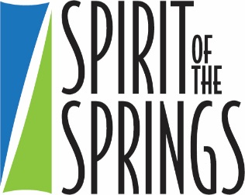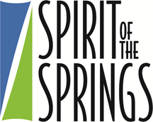

In an effort to attract high quality recruits and to diversify the corps of first responders and public safety personnel serving the citizens of Colorado Springs, the Mayor has organized an event for the past several years to garner support from across the community to fund scholarships for high achieving students seeking an Associate degree at PPCC. These funds provide scholarships for PPCC students pursuing associates degrees in Criminal Justice, Fire Science, Emergency Medical Services, or in Biology or Chemistry with an intention to pursue a career in Public Safety with the City of Colorado Springs. This scholarship is for $1,500 per semester based on full time status (24 credit hours per year) and is renewable if recipient maintains minimum requirements. The recipients of this award must maintain a GPA of 2.5 or higher to remain eligible for the scholarship.

Student Profile:
- Seeking female students from all racial backgrounds and male students who identify as African-American, Hispanic, or Asian
- Preference is given to students who are committed to pursuing careers with the Colorado Springs Fire or Police Departments
- Students must remain in good academic and disciplinary standing at PPCC while receiving the scholarship
- Students must be Colorado Springs residents
- Students must have graduated from a Colorado Springs high school within the past 10 years or separated from the United States Armed Forces with an honorable discharge within the past 5 years

Apply at www.ppcc.edu/scholarships

For additional information on the Spirit of the Springs Scholarship, contact Donna Nelson at dznelson@springsgov.com

