CREATING YOUR ON-LINE PROFILE (EXTERNAL EMPLOYEES)
STEP 1: Go to: http://aecom.jobs/ enter location in the “Where” and enter search criteria in the “What” search boxes.
STEP 2: Click on desired position. Read the description carefully and click to view more information about the position.
Click on the “Apply to Job(s)” tab. Below is a snapshot of the page.
Step 3: You will enter the Gateway Questionnaire log in/create login page. Select the “Create a login” located on the left side of the screen. Click the Agree button for the Personal Information Collection Notice and Consent.
It will prompt you to enter an email address, password, and select 3 security questions and answers. Click on the Create tab. Below is a snapshot of the page.
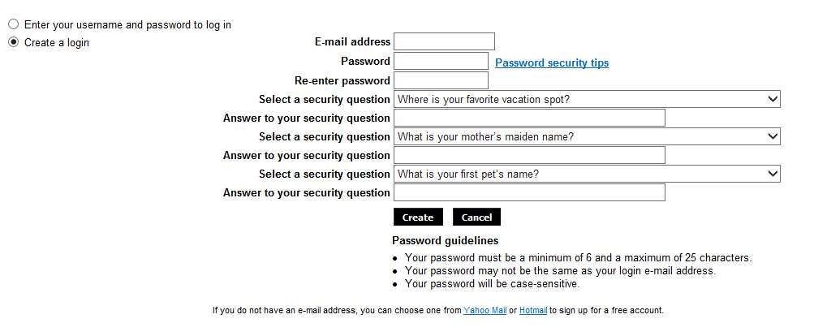
Step 4: You may import your resume, and insert all of your personal information. You can upload your resume and it will electronically extract the contents of your resume and will auto-populate some of your information. Click on the “Browse” button to locate your resume file where you have it stored. Then click on “Next” to complete the extract to your profile.
You can enter your resume by typing or copying it in the text box below. Then click on “Next” to complete the extract to your profile. You can enter your cover letter by typing or copying it in the text box below. Below is a snapshot of the page.
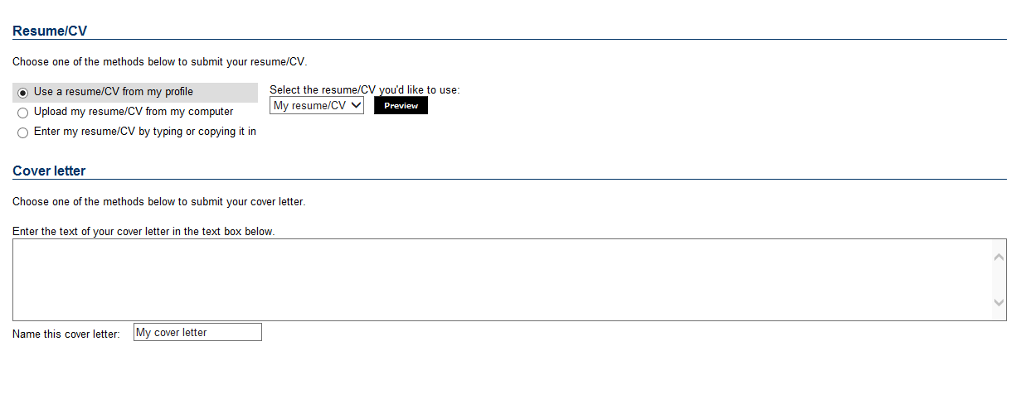
You can preview your resume that has been saved in the uploaded format. Then click on “Next”
Step 5: Please review the data to ensure all personal information is correct. Then click on “Next”
Please review the date to ensure all experience and education is correct. Reminder to click on the “Most Recent” for experience. Then click on “Next”
Please upload any attachments that would support your application. Then click on “Next”
Step 6: Please fill out the Source Data. Below is a snapshot of the page. Then click on “Next”
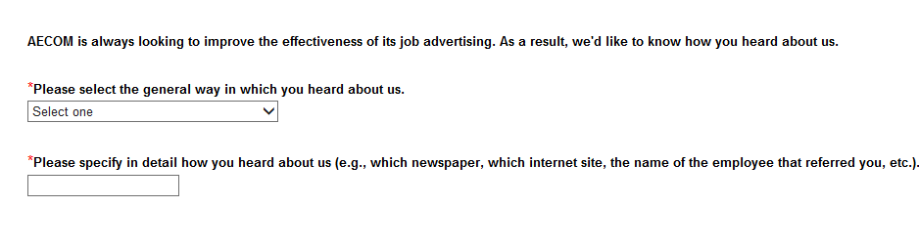
Step 7: Please review your responses, please click “Submit” button. If you need to correct anything, please click “Previous” button and edit the necessary information.
Step 8: You should see the following message after click on the “Submit” button. Below is a snapshot of the page .
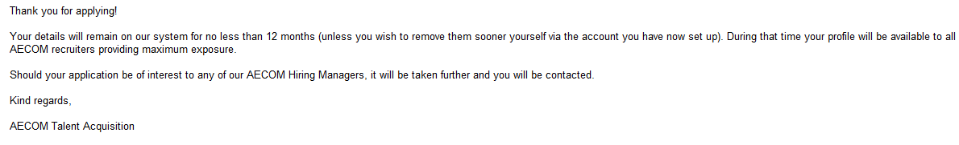
You will be redirected to the Current Job Opening page.

EDITING YOUR ON-LINE PROFILE
STEP 1: If you need to edit your go to: https://jobs.aecom.com/TGWebHost/home.aspx?PartnerId=20052&SiteId=5022
Enter your information in the “Sign in/Register” spaces, see below:

STEP 2: Click the “Sign in” button
STEP 3: At the top of the next page, click on “Candidate Zone” to see your profile page
STEP 4: You can make changes to your ”Profile” by clicking on the different sections or go “My Files” to upload a new resume and documents
STEP 5: Click the “Sign out” button when you are finished editing your profile

SEARCHING FOR JOBS IN PUEBLO
STEP 1: Go to: http://aecom.jobs/ .
STEP 2: Search “Where” Colorado. Click the search button .

NOTES:
*Be sure and keep all of your contact information current on your profile so we are able to get in contact with you.
**AECOM is a place where you can put your innovative thinking and business skills into high gear and work alongside other highly intelligent and motivated people. It's a place where you can apply your skills to some of the world's most challenging, interesting, and meaningful projects worldwide. It's a place that values the diversity of our areas of practice and our people. It's what makes AECOM a great place to work and grow. AECOM is an Equal Opportunity Employer – M/F/D/V. At AECOM, employee's safety and security are our top Safeguarding core value. All employees are expected to set the highest level of safety expectation in their work, display the highest level of safe behavior, and actively participate in AECOM's Safety For Life Program. SH&E is a part of our company culture and participation is required for all employees.
***NOTICE TO THIRD PARTY AGENCIES: Please note that AECOM does not accept unsolicited resumes from recruiters or employment agencies. In the absence of a signed Recruitment Fee Agreement, AECOM will not consider or agree to payment of any referral compensation or recruiter fee. In the event a recruiter or agency submits a resume or candidate without a previously signed agreement, AECOM explicitly reserves the right to pursue and hire those candidate(s) without any financial obligation to the recruiter or agency. Any unsolicited resumes, including those submitted to hiring managers, are deemed to be the property of AECOM.

