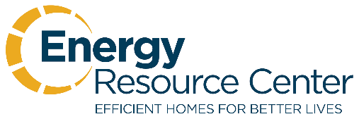
January 15, 2019

INTERNSHIP OPPORTUNITY

Energy Resource Center is offering an internship for a qualified individual to assist the Community Relations Manager with various duties. ERC is entering an exciting time in our progress as an organization. In the past 8 years, we have expanded from the original Colorado Springs location (founded in 1979), to four offices throughout the state.

Our organization improves the lives of low-income families through weatherization of their homes. This internship is a great opportunity for someone seeking a career in energy conservation and environmental stewardship.

Tasks to include:

- Blogging – Creating content for web site regarding energy savings, environmental stewardship, affordable housing, low-income family assistance, etc.

- Email Newsletter Content – Similar content to blogging above.

- Database Research – ERC is building databases for media outlets, fundraising contacts, corporate donor contacts and more.

- Social Media – ERC is planning and implementing a long-term plan for social media, video and web-based growth.

- Staff Communication – ERC has over 100 employees and four offices. We are working on increased staff communication and awareness of internal progress with above efforts.

Various additional duties are available based on individual skill-set. Qualified applicants should have strong writing and communication skills. Attentiveness to task, organizational skills and eagerness to learn are essential. However, the most important asset above others is a person who lives with passion and compassion in their heart and seeks to make the world a better place.

For more information, please contact Mike Mazzola at 719-591-0772 or mikem@erc-co.org.

Thank you!

