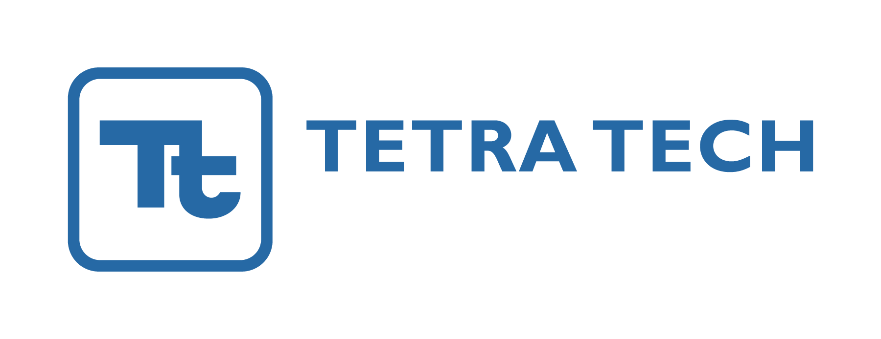

April 2, 2019 Requisition #10300000605

Job Description:

Tetra Tech Inc. is currently seeking an Administrative Assistant for the Pueblo Chemical Depot Training Department in Pueblo, CO.

The selected candidate’s major duties include:

Assist Training Office staff in the following:
- Typical administrative duties as requested.
- Maintain local database with current employees, training assignments, training attendance, etc.
- Maintain online training database with current employee data and training requirements; assign and credit training as required.
- Receive, track and process incoming training documents.
- Prepare reports from database.
- Generate certificates for specific classes and certifications.
- Maintain sensitive electronic and paper files in a secure and confidential manner/
- Assist new employees with orientation of training requirements.
- Provide assistance to employees with accessing online training classes.
- Coordinate training classroom schedules.
- Maintain Office Outlook calendar and keep office staff advised of changes.
- Monitor Office Outlook mail account.
- Maintain Office Share Point website.
- Provide assistance to auditors, retrieving files for inspection.
- Receive phone calls for staff as needed.
- Assist with housekeeping of building.
- Receive guests, visitors and depot staff; serve as initial point of contact for office.
- Provide assistance to guest speakers and instructors in the operation of A/V equipment, office equipment, computers, and set up of classrooms.
- Assist with preparing and scheduling training events and provide assistance as needed with non-training events held in building.
- Assist staff with maintaining office supplies.
- Submit help tickets and track for completion for computer equipment.
Tetra Tech is a leading provider of consulting and engineering services differentiated by Leading with Science in providing innovative technical solutions to our clients. We support global commercial and government clients focused on water, environment, infrastructure, resource management, energy, and international development. With 17,000 associates worldwide, Tetra Tech provides clear solutions to complex problems. We offer competitive compensation and benefits and are searching for innovative people to join our teams. We are an equal opportunity employer.

Job Requirements:

The ideal candidate will have minimum 2 years’ experience as an administrative assistant, preferably at a client site or in support to a federal government agency. 5+ years of relevant work experience is preferred.

The ideal candidate will be able to demonstrate the following experience:

- Computer Skills: Microsoft Office programs including Access, Word, Excel, Power Point, Outlook and Share Point; Adobe Acrobat Pro; Internet Explorer
- Excellent communication and interpersonal skills
- Excellent writing skills
- Attention to detail
- The ability to work unsupervised

This position requires you to be a U.S. citizen.

The physical demands of this position are that of a typical office environment. Minimal lifting would be required. Candidate may be required to sit or stand for extended periods of time. The candidate may be required to work at a computer for extended periods of time.

To apply, please submit your resume & cover letter online at www.tetratech.com/career. We thank all applicants for their interest; however only those selected for an interview will be contacted.
Tetra Tech is committed to diversity and gender equality in all its operations - in the U.S. and overseas. We strive to reflect these goals in our global mission and in our workplace. We encourage applications from women and underrepresented ethnic, racial, and cultural groups, veterans and persons with disabilities. Tetra Tech is proud to be an Equal Opportunity Employer.
Tetra Tech is a VEVRAA federal contractor and we request priority referral of veterans for available positions.
EOE AA M/F/Vet/Disability • No calls or agencies

