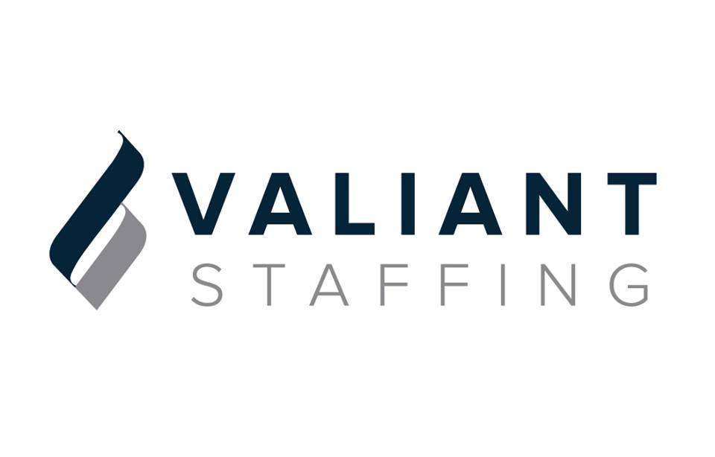
JOB OPENINGS (Aug 8, 2019)

MILLER COORS - GOLDEN
*Forklift Operator/Warehouse
*Bottling and Keg
*Packaging and Shipping
$16/HR (1ST and 2ND Shift Available), 10 Openings

FEDEX/ GE Whirlpool- AURORA
*Forklift Operators-$15-17/HR DOE-(Day or Night),6 Openings

RRR/ INSTEL STEEL – COMMERCE CITY
*Material Handlers/Forklift Operator-$15/HR
*Table Saw Operator-$14-16/HR, DOE 2 Openings

HENSEL PHELPS CONSTRUCTION-DENVER
*Field Engineer-$55-65K, DOE
*Construction Laborer-$15/HR
*Carpenter- $15-20/HR, DOE

PVM STEEL-Denver
*Material Handlers-$15-17/HR, DOE, 2 Openings
RELIANCE METAL CENTER/COLORADO SPRINGS
*Material Handlers/ Skilled laborer-$14-15/HR DOE

ROLLING PLAINS CONSTRUCTION/ COLORADO SPRINGS/DENVER
*Skill labor trades (No Experience)-$15-17/HR, 30 Openings Travel

GLOBAL COMMS EXCHANGE/ COLORADO SPRINGS
*Manufacturing Tech-$15-25/HR, DOE, 6 Openings (Secret Clearance or Eligible to get one)

BALL AEROSPACE - DENVER
*ADMINISTRATIVE ASSISTANT III- Ball Aerospace-$22.70
*ANYTHING TS/SCI

PLEASE CONTACT:
ERIK CRUZ, VP OF RECRUITING
600 S. CHERRY ST, SUITE #105
DENVER, CO 80246
ERIK@VALIANTSTAFFINGCO.COM
O: 720.277.3421
C: 719.232.5159

