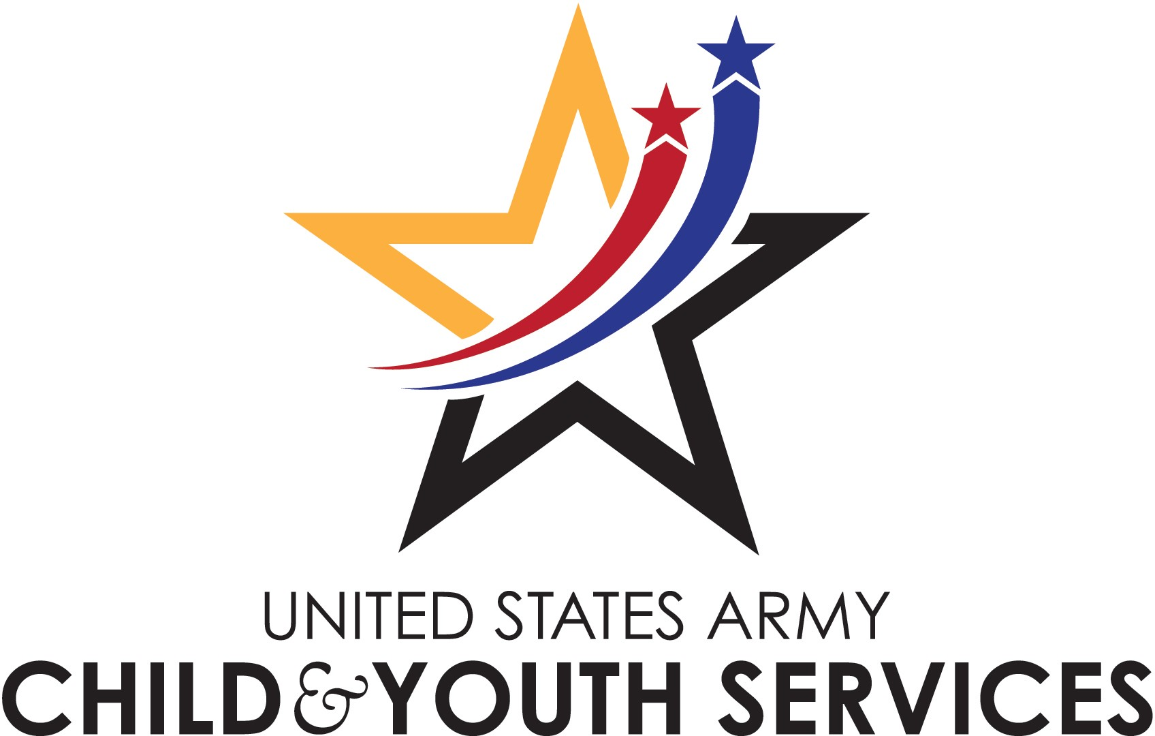
2018 Youth Sports Calendar

Sport | Registration Dates | Ages & Costs | First Practices | Last Games
Winter Basketball Developmental | November 6-December 8 | 3-4 yrs.  $25.00 | January 8 | February 24
Winter Basketball | November 6-December 8 | 5-18 yrs.  $45.00 | January 8 | February 24
Winter Cheerleading Developmental | November 6-December 8 | 3-4 yrs.  $25.00 | January 8 | February 24
Winter Cheerleading | November 6-December 8 | 5-18 yrs.  $45.00 | January 8 | February 24
Winter Wrestling | November 6-December 8 | 6-15 yrs.  $45.00 | January 8 | February 24
Spring Soccer Developmental | February 12-March 16 | 3-4 yrs.  $25.00 | April 2 | May 26
Spring Soccer/Flag Football | February 12-March 16 | 5-18 yrs.  $45.00 | April 2 | May 26
Tennis | February 12-March 16 | 5-15 yrs.  $45.00 | April 2 | May 26
Girls Softball | April 16-May 18 | 7-15 yrs.  $45.00 | June 4 | August 3
Track & Field | April 16-May 18 | 6-15 yrs.  $45.00 | June 4 | August 3
Summer T-Ball Developmental | April 16-May 18 | 3-4 yrs.  $25.00 | June 4 | August 3
Summer T-Ball (5-6) & Baseball | April 16-May 18 | 5-18 yrs.  $45.00 | June 4 | August 3
Volleyball | July 23-August 24 | 7-15 yrs.  $45.00 | September 10 | November 10
Fall Soccer Developmental | July 23-August 24 | 3-4 yrs.  $25.00 | September 10 | November 10
Fall Soccer | July 23-August 24 | 5-18 yrs.  $45.00 | September 10 | November 10
Fall Cheerleading Developmental | July 23-August 24 | 3-4 yrs.  $25.00 | September 10 | November 10
Fall Cheerleading | July 23-August 24 | 5-18 yrs.  $45.00 | September 10 | November 10
Fall Flag Football | July 23-August 24 | 5-18 yrs.  $45.00 | September 10 | November 10
Indoor Soccer | October 8-November 2 | 5-12 yrs.  $45.00 | November 14 | December 21
Fall Wrestling | October 8-November 2 | 6-15 yrs.  $45.00 | November 14 | December 21
THE ABOVE INFORMATION IS SUBJECT TO CHANGE BASED ON VOLUNTEER COACHES, ENROLLMENT, AVAILABLE PARTNERS, AND FACILITY/PRACTICE SPACE

TO REGISTER FOR SPORTS, PLEASE VISIT PARENT CENTRAL REGISTRATION IN BUILDING 1518.
APPOINTMENTS CAN BE MADE BY CALLING (719) 526-1101
A SPORTS PHYSICAL IS REQUIRED TO PARTICPATE IN ALL YOUTH SPORTS ACTIVITIES
FOR QUESTIONS REGARDING PROGRAM, PLEASE CALL THE SPORTS STAFF AT (719) 526-4425

