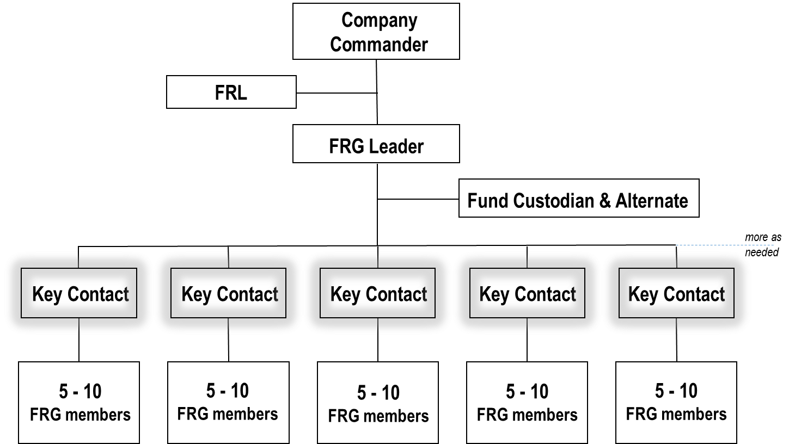

SAMPLE Roster of Assigned FRG Members
FRG Member Name | Home Phone # | Office Phone # | Cell Phone # | Email Address | Emergency Contact (Friend/Neighbor) | Emergency Contact Phone #

