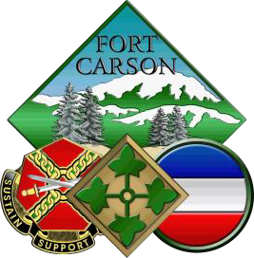

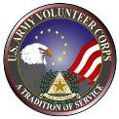

4th ID and Fort Carson Annual Volunteer Award Recognition

6 May 2026, 1300-1500
Location: TBA

Award Nomination Packets for:

Fort Carson Commanding General’s
Certificate of Appreciation

Nomination Due: 27 February 2026

Calendar Year of Volunteer Service being recognized:

1 January 2025- 31 December 2025

The point of contact for all awards: Cynthia Brisby, Fort Carson Army Volunteer Program Manager. Additional information can be obtained by calling (719) 526-1082 / (719) 425-5009 or emailing cynthia.a.brisby.civ@army.mil
Email nomination packets to:
AVC Office usarmy.carson.id-readiness.list.dfmwr-acs-army-volunteer-corp@army.mil
Division CFRR jack.m.luth.mil@army.mil

Fort Carson Commanding General’s
Certificate of Appreciation

Award  Description | The Fort Carson ‘Commanding General’s (CG’s) Certificate of Appreciation (COA)’ recognizes any outstanding volunteer annually.
Award  Presentation | The COA is presented at the time and venue of the unit/directorate/organization’s discretion.  This is not presented at the Fort Carson Annual Installation Volunteer Award Recognition. The COA will be given to the  unit/directorate/organization to be presented at their respective/internal Volunteer award recognition. Those submitting a memorandum should coordinate with the AVCC to ensure award memorandums are received, processed, and will be available for their internal volunteer recognition ceremony.
Components | Certificate signed by the Installation Commanding General.
Approving  Authority | Fort Carson Commanding General
Criteria | - Any Fort Carson volunteer who has served within the Unit/Directorate/Organization throughout the calendar.  - Those volunteers submitted by units/organizations will receive the COA  - Units, Directorate and Agencies are responsible to submit the memorandum to the AVCC to be processed submission due date/
Submission  Packet | - One memorandum with all eligible volunteer names listed along with the unit/organization POC.  - Memorandum must be signed by the Commander and/ Director  - No individual citation is required for this award.
Staffing  Channels | - Submit signed memorandum to the AVCC by the suspense date for annual awards ceremony..

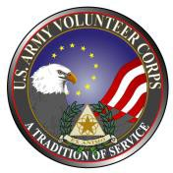 | NOMINATION FORM FOR:  FORT CARSON CERTIFCIATE OF APPRECIATION  Fort Carson Annual Volunteer Recognition Due Date: 27 February 26  (THIS FORM MAY BE DUPLICATED)

PART I – NOMINEE INFORMATION

NOMINATION FOR: Fort Carson Certificate of Appreciation___________________
VOLUNTEER NAME: PLEASE SEE ATTACHED MEMO FOR LIST OF NAMES___
NOMINATING AGENCY: ________________________________________________

NOMINATOR: _________________________________________________________
(Print or Type Name) (Signature)

EMAIL:
PHONE:________________________________________________________________

PART II –JUSTICATION MEMORANDUM

SUBMIT ALL REQUIRED DOCUMENTS TO THE AVCC, BUILDING 1526, TEL 526-1082.

JUSTIFICATION MEMORANDUM
FORT CARSON COMMANDING GENERAL’S CERTIFCATE OF APPRECTION
(EXAMPLE)

Office Symbol Date

MEMORANDUM FOR Army Volunteer Corps Office, ATTN: AVCC, 6303 Wetzel Ave, Bldg. 1526 , Fort Carson, Colorado 80913

SUBJECT: Fort Carson Commanding General’s Certificate of Appreciation

- Request for the following Volunteers to receive the Fort Carson Commanding General’s Certificate of Appreciation:

- SSG John Doe
- CPT Jane Smith
- William Jones
- Betty White

- POC is (name of nominator), (phone number).
(SIGNATURE BLOCK)
Commander/Director

