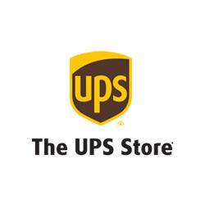
The UPS store on Fort Carson is looking for a part-time/full-time employee. No experience is required. Must be friendly and dedicated to providing excellent customer service. Store hours are 0700-1800 Monday-Friday, and must be able to work the occasional Saturday from 1000-1500.
Please send your resume to: store5039@theupsstore.com (719) 527-6800

