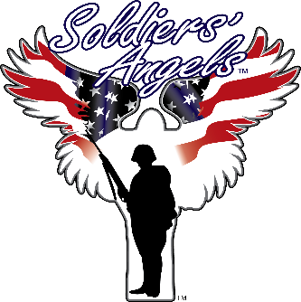
Soldiers’ Angels
Fact Sheet 2019

Mission
Soldiers’ Angels is a national charity providing aid and comfort to the men and women of the United States Army, Marines, Navy, Air Force, Coast Guard, and their families and a growing veteran population.

What We Do
Thousands of Soldiers’ Angels ‘Angel’ volunteers work tirelessly to assist veterans, wounded, deployed personnel, and their families in a variety of unique and effective ways. “May No Soldier Go Unloved" encapsulates the motivation behind Soldiers' Angels.

Key Strengths
- The largest volunteer network of any charity of its kind in the country
- Provided over $147M in aid to military and veteran families since 2003
- Holds the highest level of recognition from the world’s largest source of nonprofit information, the Platinum Seal of Transparency from GuideStar
- Earned the highest possible rating (four stars) with Charity Navigator, the nation’s most-utilized charity evaluator
- Maintains an efficiency rating of 96.5%, which is substantially above that of the average nonprofit organization • Fully Accredited by the Better Business Bureau
- Named as one of the top rated charities in America for the past 5 years by Great Nonprofits
- Served over 24,650 veterans with food assistance in 2018
- Provided support to 513,358 service members, veterans and family members in 2018
- Provided over 39,995 items to veterans at VA Medical Facilities in 2018
- Sent over 879,600 care packages to combat deployed service members over the last 15 years

Programs and Services
Soldiers’ Angels offers “boots on the ground” and “virtual” programs and services. This allows the organization to best serve our military families and veterans while also ensuring we fully utilize the resources of our dedicated volunteers.

Soldiers’ Angels operates 12 virtual teams, where volunteers from all over the country and even internationally can participate in supporting US military and US veterans. Our “virtual” teams include:
- Deployed Adoptions Team • Baby Brigade Team
- Ladies of Liberty Team • Women of Valor Team
- Angel Bakers Team • Living Legends Team
- Chaplain Support Team • Cards Plus Team
- Letter Writing Team • Sewing & Crafting Team
- Special Operations Forces Team • Adopt-A-Family Team

Soldiers’ Angels staff and volunteers work tirelessly to provide aid and comfort support to military families and veterans. Most of this work is directed towards the VA Medical Centers and homeless veterans. Our services include:
- Patient Visits • Monthly Food Distributions
- Luncheons/Dinners • Break room supplies
- Hygiene Kits • Stand Down Support (homeless veterans)
- Box Lunches • Valor IT

For further information, contact:
2895 NE Loop 410, Suite 107  San Antonio, TX 78218  210-629-0020  Email: info@soldiersangels.org www.soldiersangels.org  Tax ID # 20-0583415

